
With you
معك
A systems analysis and design document submitted to Khan Younis Training College for the degree of Technical Diploma as a part of the graduation project in the specialization of E-Business Program

Prepared By:
Samiha Osrof, Basil Abu Arada, Malak
Mutair, Malak Abu Amra, Sally Sobeh,
Dina Abu Youssef, Mays Abu amona

Supervised By:
Mr.Raed Felfel

E-Business Program
2023 – 2024

Acknowledgement

Table of Content
Acknowledgement II
Table of Content III
Table of Tables V
Table of Figures V
Table of Acronyms VI
Abstract VII
Chapter 1 Introduction 8
1.1 System Description 8
1.2 System Objectives 8
1.2.1 Business Objectives 8
1.2.2 Team Objectives 8
1.3 Competitors Analysis 8
Chapter 2 Planning 9
2.1 Methodology 9
2.2 Initial Timeline 9
Chapter 3 Requirements Analysis 10
3.1 System Users 10
3.2 Functional Requirements 10
3.2.1 User-1 Functional Requirements 10
3.2.2 User-2 Functional Requirements 10
3.3 Non-Functional Requirements 10
Chapter 4 System Models 11
4.1 Use Cases 11
4.1.1 User-1 Use Cases 11
4.1.2 User-2 Use Cases 11
4.2 Data Flow Diagram 11
4.2.1 Context Data Flow Diagram 11
4.2.2 Level-0 Data Flow Diagram 11
4.2.2.1 User-1 Level-0 Data Flow Diagram 11
4.2.2.2 User-2 Level-0 Data Flow Diagram 11
4.3 Entity Relationship Diagram 11
Chapter 5 System Specification 12
5.1 The Used Technologies 12
5.2 Database Physical Model 12
5.3 Wireframes 12
5.3.1 User-1 Wireframes 12
5.3.2 User-1 Wireframes 12

Table of Tables
Table ‎41: User Registration Use Case 9
Table ‎42: User Login Use Case 9
Table ‎43: Search for Psychologist Use Case 10
Table ‎44:Book a session Use Case 10
Table ‎45:Rate Psychologist Use Case 10
Table ‎46: Read Awareness Articles Use Case 11
Table ‎47: Accept/Reject Session Request Use Case 11
Table ‎48:Send Message in Chat Use Case 11
Table ‎49: Receive Notifications Use Case 12
Table ‎410:Manage Awareness Content Use Case 12
Table ‎411: Manage User Accounts Use Case 12

Table of Figures
Figure ‎21: Waterfall Methodology 3
Figure ‎41:context Diagram 12
Figure ‎42:User Level 0 13
Figure ‎43:Psychologist Level 0 14
Figure ‎44: ERD 15
Figure ‎51:Wireframe Login 16
Figure ‎52:Wireframe Sign in 16
Figure ‎53:Wireframe Home page 17
Figure ‎54:Wireframe Psychologist page1 18
Figure ‎55: Wireframe Psychologist page2 18
Figure ‎56: Wireframe Articles 19

Table of Acronyms

Abstract

Introduction

System Description
A platform that aims to provide psychosocial support to individuals suffering from psychosocial problems or emotional trauma and are interested in psychotherapy. The platform allows users to share their feelings and problems in privacy environment, provides counseling services by professional psychologists, and works to provide effective solutions that help raise awareness of psychosocial and achieve recovery.

System Objectives

Business Objectives
Connecting people with qualified psychologists based on their conditions in order to provide psychological support to those who are in need and those who are interested in psychological therapy. This is accomplished by offering secure environments in which individuals can communicate their emotions and issues and come to agreeable resolutions through sessions that are scheduled by the psychologist at reasonable costs and questionnaires that they are requested to complete in order to gauge their circumstances. The case owner can also share their success story on the platform and openly review the specialist who treated them. Articles promoting awareness of social and psychological issues are also available on the platform. For psychopaths requiring long-term care, monthly subscriptions are also an option.

Team Objectives
- - Help the people of Gaza overcome the psychological effects of war trauma by encouraging them to use this system.

- - Provide flexible payment options and pricing plans that suit all groups.

- - Build a comprehensive platform that fosters trust in psychosocial treatment and helps reduce social stigma.

- - Regularly test the system to ensure performance, stability, and meet user expectations.

- - Collaborate with mental health professionals to develop high-quality services.

- - Market the platform to increase its adoption by patients and specialists.

Competitors Analysis
Our platform offers several key features to support users, which differentiate it from this platform shezlong(https://www.shezlong.com/ar) in the following ways:

1. Issue Description Flexibility: Users can describe their issue even if they are unsure of its type.
2. Free Session for First-Time Users: We provide a free session for first-time users.
3. Unique Identification Number: Each user is provided with a unique identification number to enhance security and privacy.
4. Psychological First Aid: We allow users to request initial psychological first aid for those who have just experienced trauma or have not received any psychological intervention after the trauma. This request is prioritized for specialists to address as soon as possible.
5. Psychological Awareness Articles: We offer educational and awareness articles on mental health topics.
6. Success Stories: We share success stories from therapy to encourage other individuals to seek treatment.

These features provide added support for our users compared to the mentioned platform.

Planning

Methodology
The Waterfall methodology is based on executing the project in sequential phases, starting with requirements gathering, followed by system design, implementation, testing, deployment, and finally maintenance. Progression to the next phase is only possible after the completion of the previous one. This methodology is characterized by its clear steps and ease of management, with comprehensive documentation, making it suitable for projects with well-defined and stable requirements. Additionally, it provides a clear vision of the project timeline and costs from the beginning, facilitating planning and control. It is also highly suitable for small teams or projects that do not require continuous interaction with users during development, ensuring stability in the process and systematic execution.
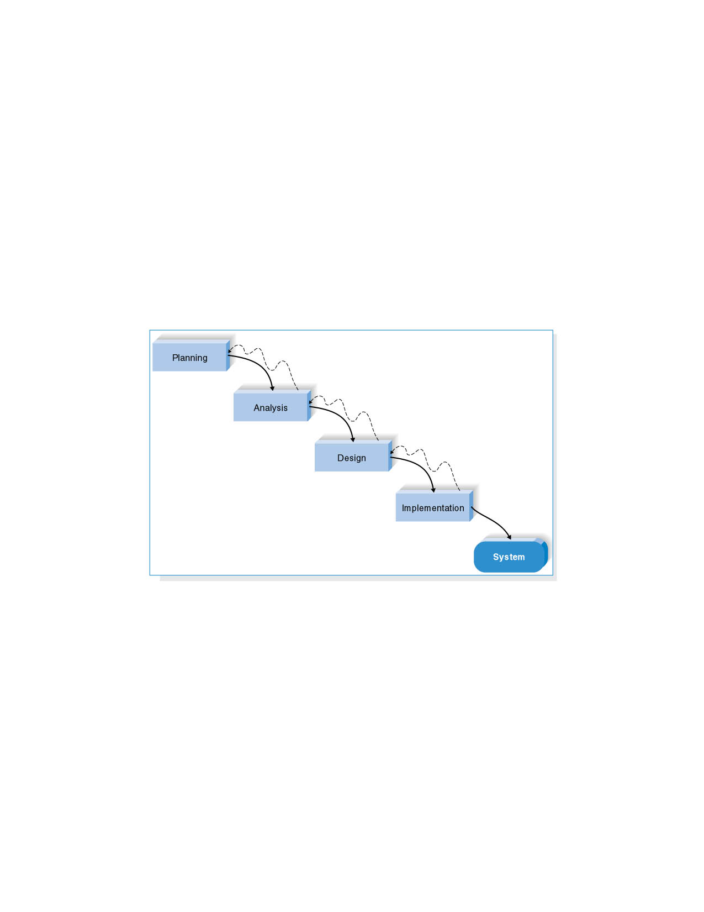
Figure ‎21: Waterfall Methodology

Initial Timeline
1. System Design:
- Duration: 3 weeks
- Dates: February 20 - March 13
Tasks:
- Frontend Design:
  - Define the overall structure of the website/application using HTML/CSS.
  - Determine the user flow and create interfaces for different user categories (e.g., counselors, patients, administrators).
- Backend Technologies Selection:
  - Choose appropriate backend technologies.
  - Define the database system.
2. Implementation:
- Duration: 6 weeks
- Dates: March 14 - May 1
Tasks:
- Frontend:
  - Develop interactive user interfaces.
  - Design booking pages for consultations, chat support, and providing guidance.
  - Connect the frontend with the backend.
- Backend:
  - Set up user management system (registration, login, password management).
  - Store user and chat data.
  - Develop notification or alert systems for users.
3. Testing:
- Duration: 3 weeks
- Dates: May 2 - May 23
Tasks:
- Conduct tests on the Frontend and Backend.
- Perform integration tests between Frontend and Backend.
- Test page load performance.
- Conduct database tests to ensure correct queries and performance.
- Test security measures (encryption and data protection).
4. Deployment:
- Duration: 1 week
- Dates: May 24 - May 31
Tasks:
- Deploy both Frontend and Backend on available servers.
- Ensure the system works correctly.
- Monitor and evaluate the system after deployment to address any issues that may arise.

Requirements Analysis

System Users
1. User: Individuals who need psychological support and wish to consult with professional psychologists.
2. Psychologist: Licensed psychologists and therapists registered in the system to provide counseling sessions.
3. Admin: Supervisors of the platform responsible for managing users, content, and reports.

Functional Requirements

User-1 Functional Requirements (User)
- Create an account and log in using email.
- Browse the list of available psychologists based on specialty and ratings.
- Book a counseling session with a psychologist.
- Fill out a questionnaire to assess mental health status before the session.
- Read educational articles about mental health.
- Submit a review and rating for the psychologist after the session.

User-2 Functional Requirements (Psychologist)
- Register an account as a service provider and add professional information and certifications.
- Accept or reject counseling session requests.
- Manage the schedule and upcoming sessions.
- Communicate with clients via chat.
- Access reports of previous cases to follow up with patients.
- Provide scientific articles or educational content for the platform.

User-3 Functional Requirements (Admin)
- The ability to create, update, and delete user accounts (psychologists and clients).
- Manage articles, educational content, and other resources on the platform.
- Session Management: Monitor and manage counseling sessions, including approving or rescheduling them if necessary.
- Create and review reports related to user activities, sessions, feedback, and platform performance.
- Assign permissions and roles to different types of users.
- Monitor system performance, security, and user behavior to ensure smooth operations.
- Send notifications to users about updates, appointments, and new content.
- Review and manage user feedback on psychologists, sessions, and overall platform experience.

Non-Functional Requirements
- Compliance: Adherence to laws and regulations related to data protection.
- Compatibility: Support for various devices and operating systems (such as mobile phones, desktops, and different browsers).
- Usability: Design a simple and user-friendly interface to ensure a smooth experience for users from diverse backgrounds.
- Maintainability: Ability to perform updates and routine system maintenance easily without significantly affecting users.
- Flexibility: The ability to modify the system or add new features based on future needs.

System Models

Use Cases

User-1 Use Cases (User)

Table ‎41: User Registration Use Case
Use case name: User Registration | ID: UC-01 | Priority: High
Actor: User
Description: The system allows the user to create a new account by entering their information, such as name, email, and password. The system then verifies the data and sends an account activation link.
Trigger: User selects "Create New Account"
Type: External
Preconditions:
- User has not registered previously.
- User must have a valid email address.

Table ‎42: User Login Use Case

Use case name: User Login | ID: UC-02 | Priority: High
Actor: User
Description: The user enters their login credentials (email and password) to access their account. If correct, they are directed to the dashboard.
Trigger: User selects "Login"
Type: External
Preconditions:
- User has an active and verified account.
- User knows their login credentials.

Table ‎43: Search for Psychologist Use Case
Use case name: Search for Psychologist | ID: UC-03 | Priority: High
Actor: User
Description: The user can search for a psychologist based on specialty, ratings, or availability. A list of available psychologists is displayed.
Trigger: User selects "Search for Psychologist"
Type: External
Preconditions:
- User is logged in.
- The system has available psychologists listed with their specialties and ratings.

Table ‎44:Book a session Use Case
Use case name: Book a session | ID: UC-04 | Priority: High
Actor: User
Description: The system allows the user to select an available psychologist and book a session based on available time slots. A booking confirmation is sent to both the user and the psychologist.
Trigger: User selects "Book a Session"
Type: External
Preconditions:
    - User is logged in.
    - User has a valid payment method activated.
    - Psychologist has available timeslots.

Table ‎45:Rate Psychologist Use Case
Use case name: Rate Psychologist | ID: UC-05 | Priority: Medium
Actor: User
Description: The system allows the user to rate the psychologist based on their experience and provide comments on the session quality.
Trigger: The session ends.
Type: External
Preconditions:
    - The user attended the entire session.
    - The system provides a rating mechanism for the session.

Table ‎46: Read Awareness Articles Use Case
Use case name: Read Awareness Articles | ID: UC-06 | Priority: Low
Actor: User
Description: The user can browse and read articles on psychosocial support and psychological therapy published by psychologists.
Trigger: User opens the awareness articles section.
Type: External
Preconditions:
    - User has an active account.
    - Articles are available in the system.

User-2 Use Cases (Psychologist)
Table ‎47: Accept/Reject Session Request Use Case
Use case name: Accept/Reject Session Request | ID: UC-07 | Priority: High
Actor: Psychologist
Description: The psychologist can review incoming requests and accept or reject them based on their availability. The user is notified of the decision.
Trigger: Psychologist receives a new session request.
Type: External
Preconditions:
    - The user has booked a session with the psychologist.
    - The psychologist has a valid profile and schedule.

Table ‎48:Send Message in Chat Use Case
Use case name: Send Message in Chat | ID: UC-08 | Priority: Medium
Actor: User and Psychologist
Description: The user and psychologist can exchange text messages within the system for inquiries or follow-up after a session.
Trigger: User or psychologist starts a chat session within the system.
Type: External
Preconditions:
    - User has an active session with the psychologist or an ongoing query.
    - The chat system is available for communication.

Table ‎49: Receive Notifications Use Case
Use case name: Receive Notifications | ID: UC-09 | Priority: High
Actor: User and Psychologist
Description: The user or psychologist receives instant notifications about upcoming sessions, updates, or new messages in the chat.
Trigger: A session is scheduled, or a new message is received.
Type: External
Preconditions:
    - The user or psychologist has an active account.
    - Notification system is enabled.

User-3 Use Cases (Admin)
Table ‎410:Manage Awareness Content Use Case
Use case name: Manage Awareness Content | ID: UC-010 | Priority: Medium
Actor: Admin
Description: The admin can add, modify, or remove awareness articles and other related content on psychosocial support.
Trigger: Adding new content or updating articles.
Type: External
Preconditions:
    - Admin has control permissions over content.
    - There is available content to be added or updated.

Table ‎411: Manage User Accounts Use Case
Use case name: Receive Notifications | ID: UC-011 | Priority: High
Actor: User and Psychologist
Description: The admin can approve new psychologist registrations, disable inactive accounts, or take administrative actions when necessary.
Trigger: New registration requests or account issues.
Type: External
Preconditions:
    - Admin has control permissions over user accounts.

Data Flow Diagram

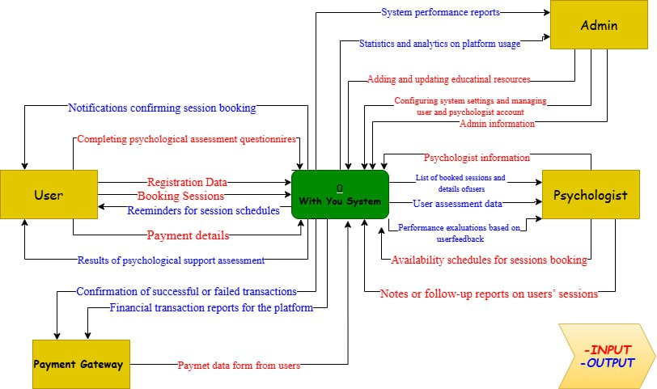
Context Data Flow Diagram

Figure ‎41:context Diagram

Level-0 Data Flow Diagram

User Level-0 Data Flow Diagram
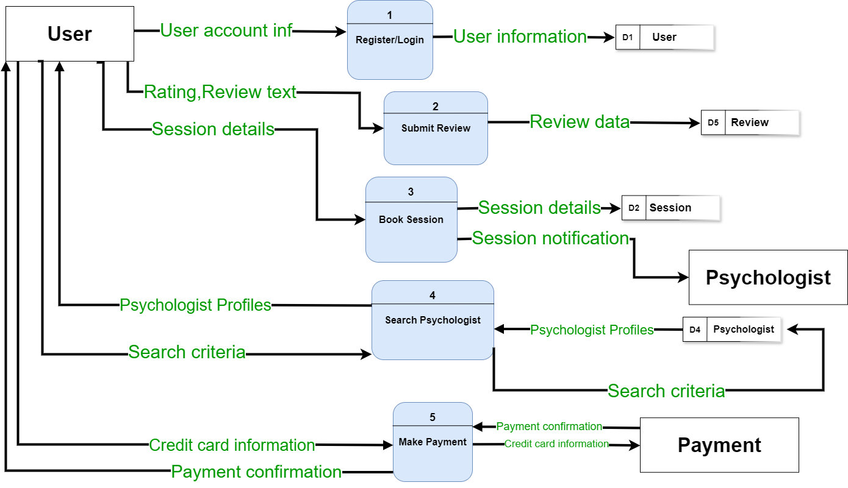
Figure ‎42:User Level 0

Psychologist Level-0 Data Flow Diagram

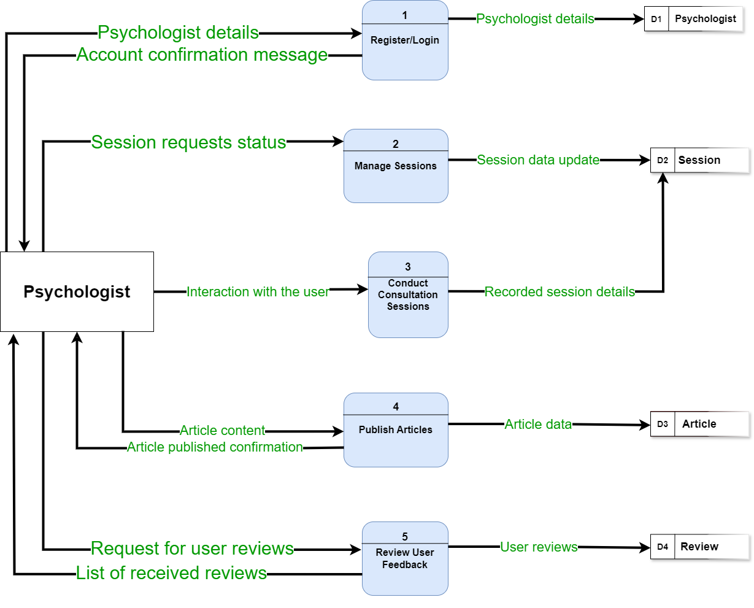
Figure ‎43:Psychologist Level 0

Entity Relationship Diagram
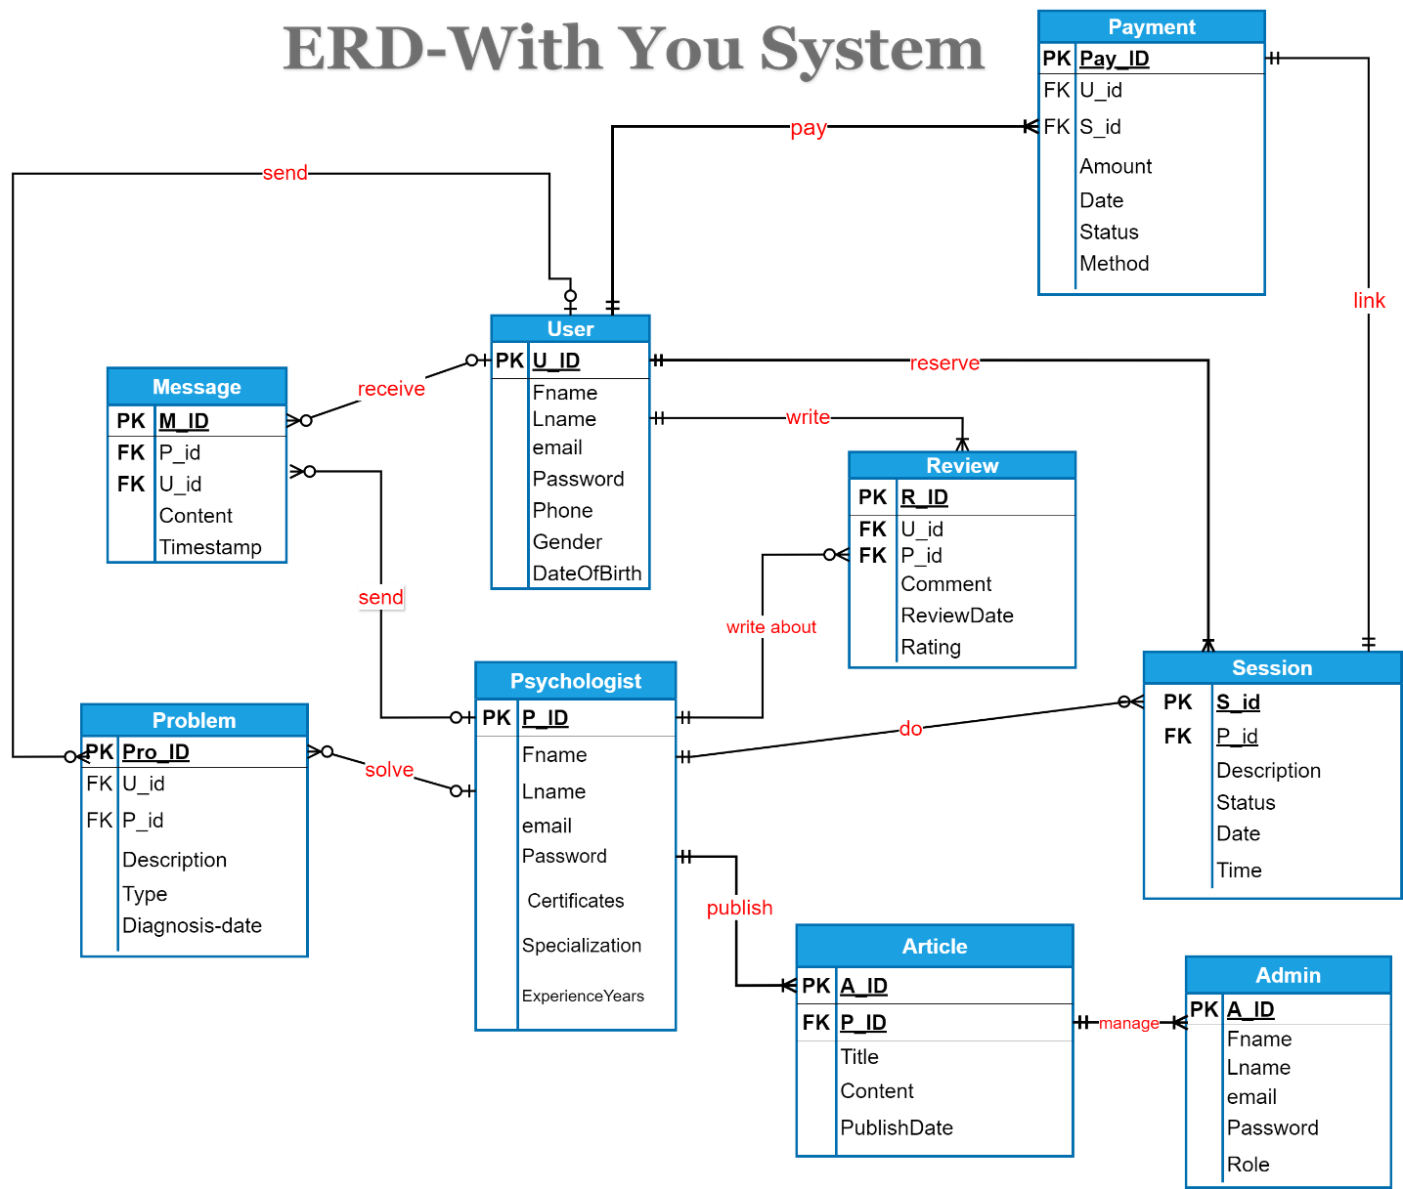
Figure ‎44: ERD

System Specification

The Used Technologies
5.1 The Used Technologies
Frontend:HTML, CSS, JavaScript.
Backend:A programming language such as JavaScript with Node.js.
Database:SQL will be used to manage user data and therapy sessions.

Database Physical Model

Wireframes

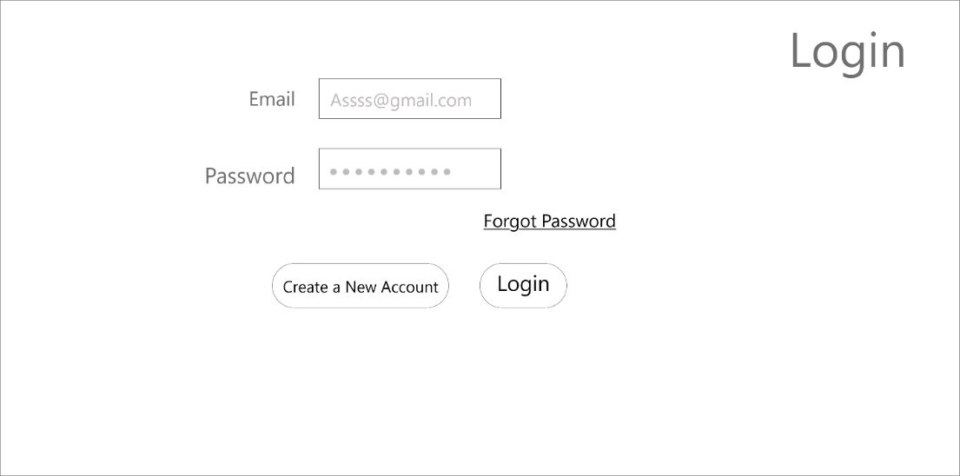
User-1 Wireframes

User-1 Wireframes

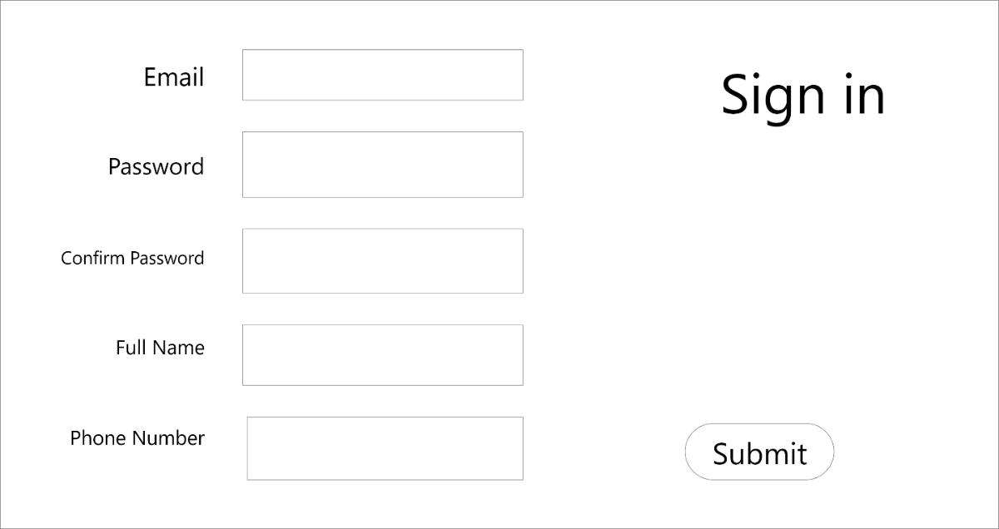

Figure ‎51:Wireframe Login

Figure ‎52:Wireframe Sign in

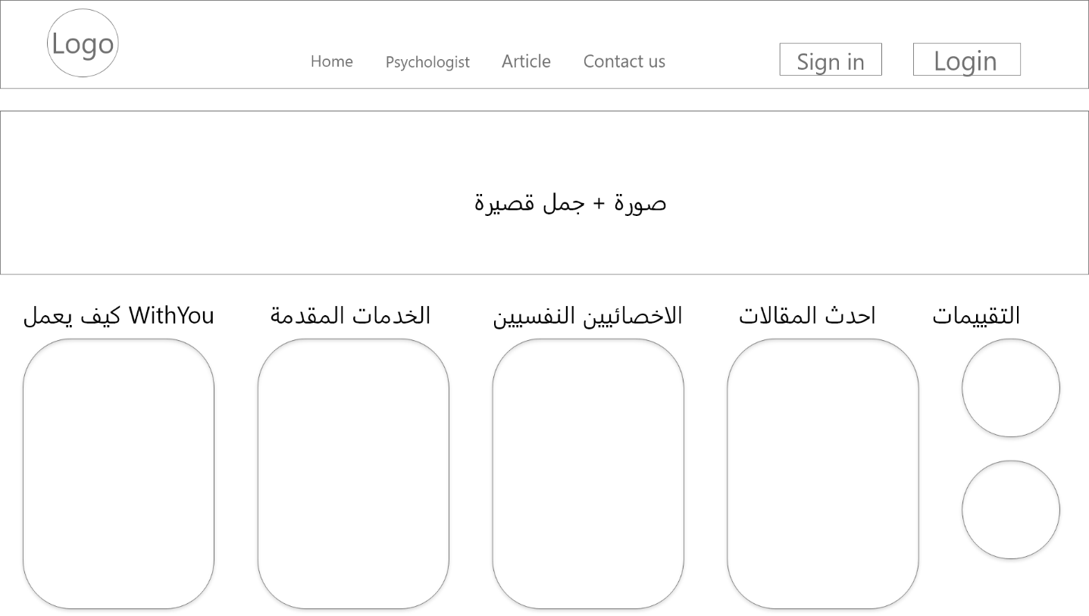
Figure ‎53:Wireframe Home page

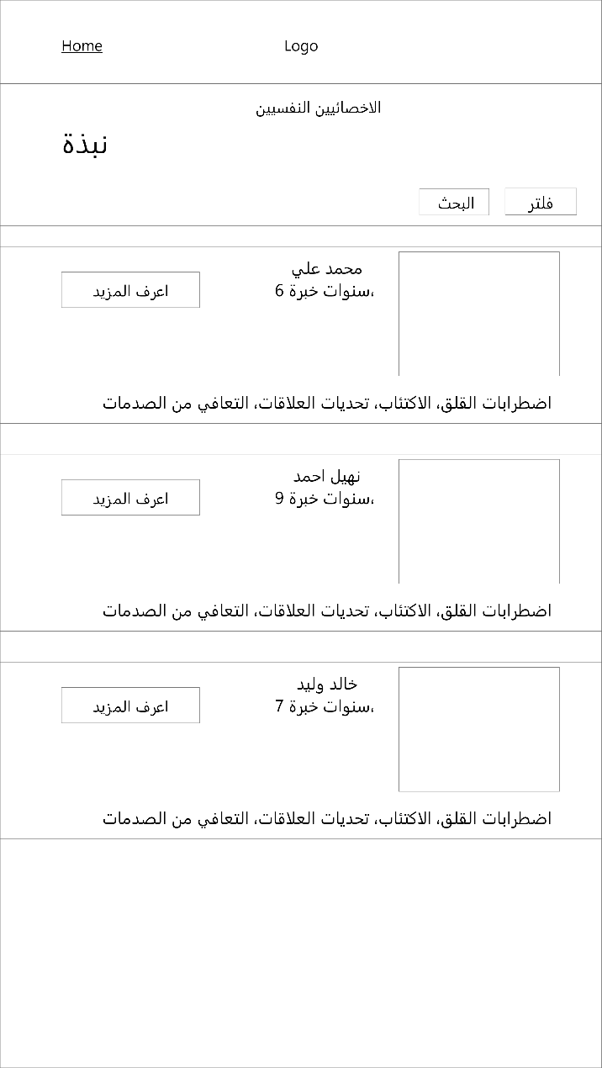

Figure ‎54:Wireframe Psychologist page1

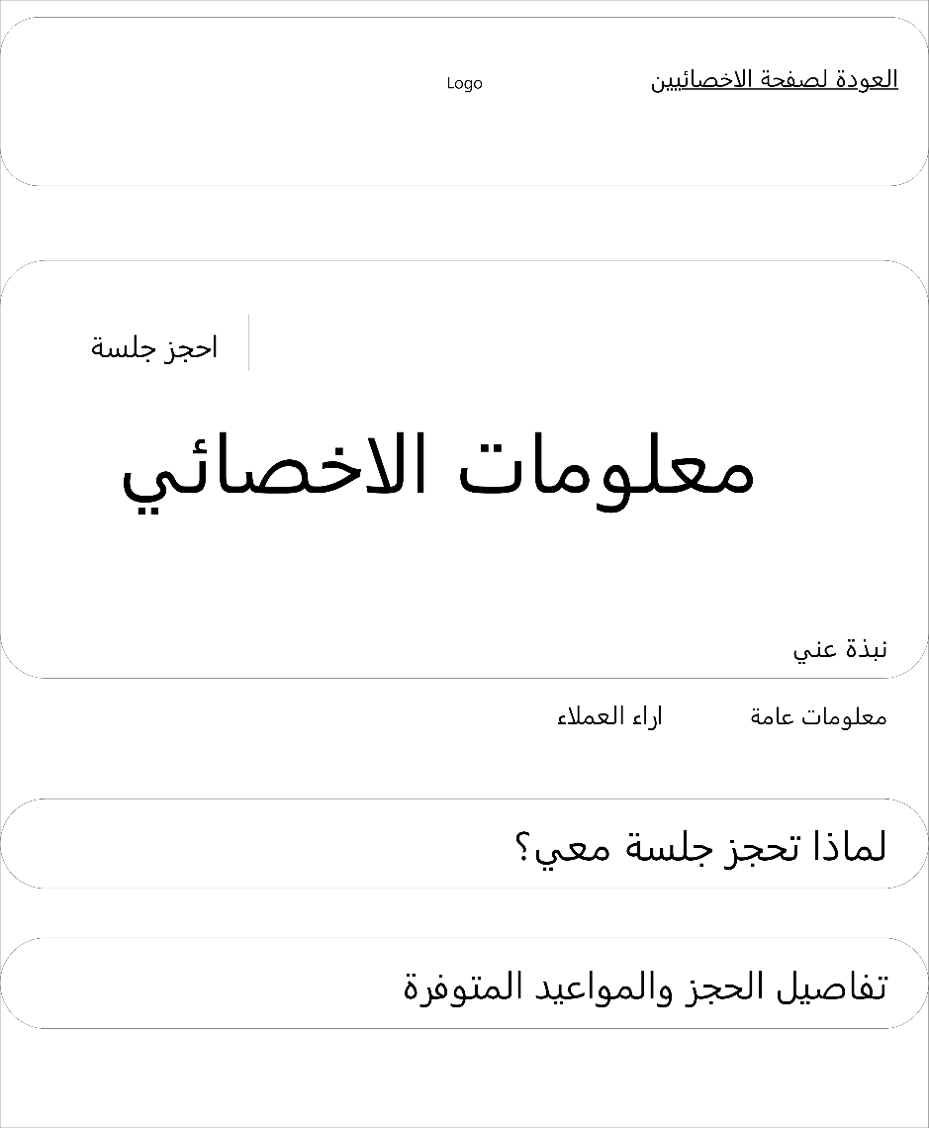
Figure ‎55: Wireframe Psychologist page2

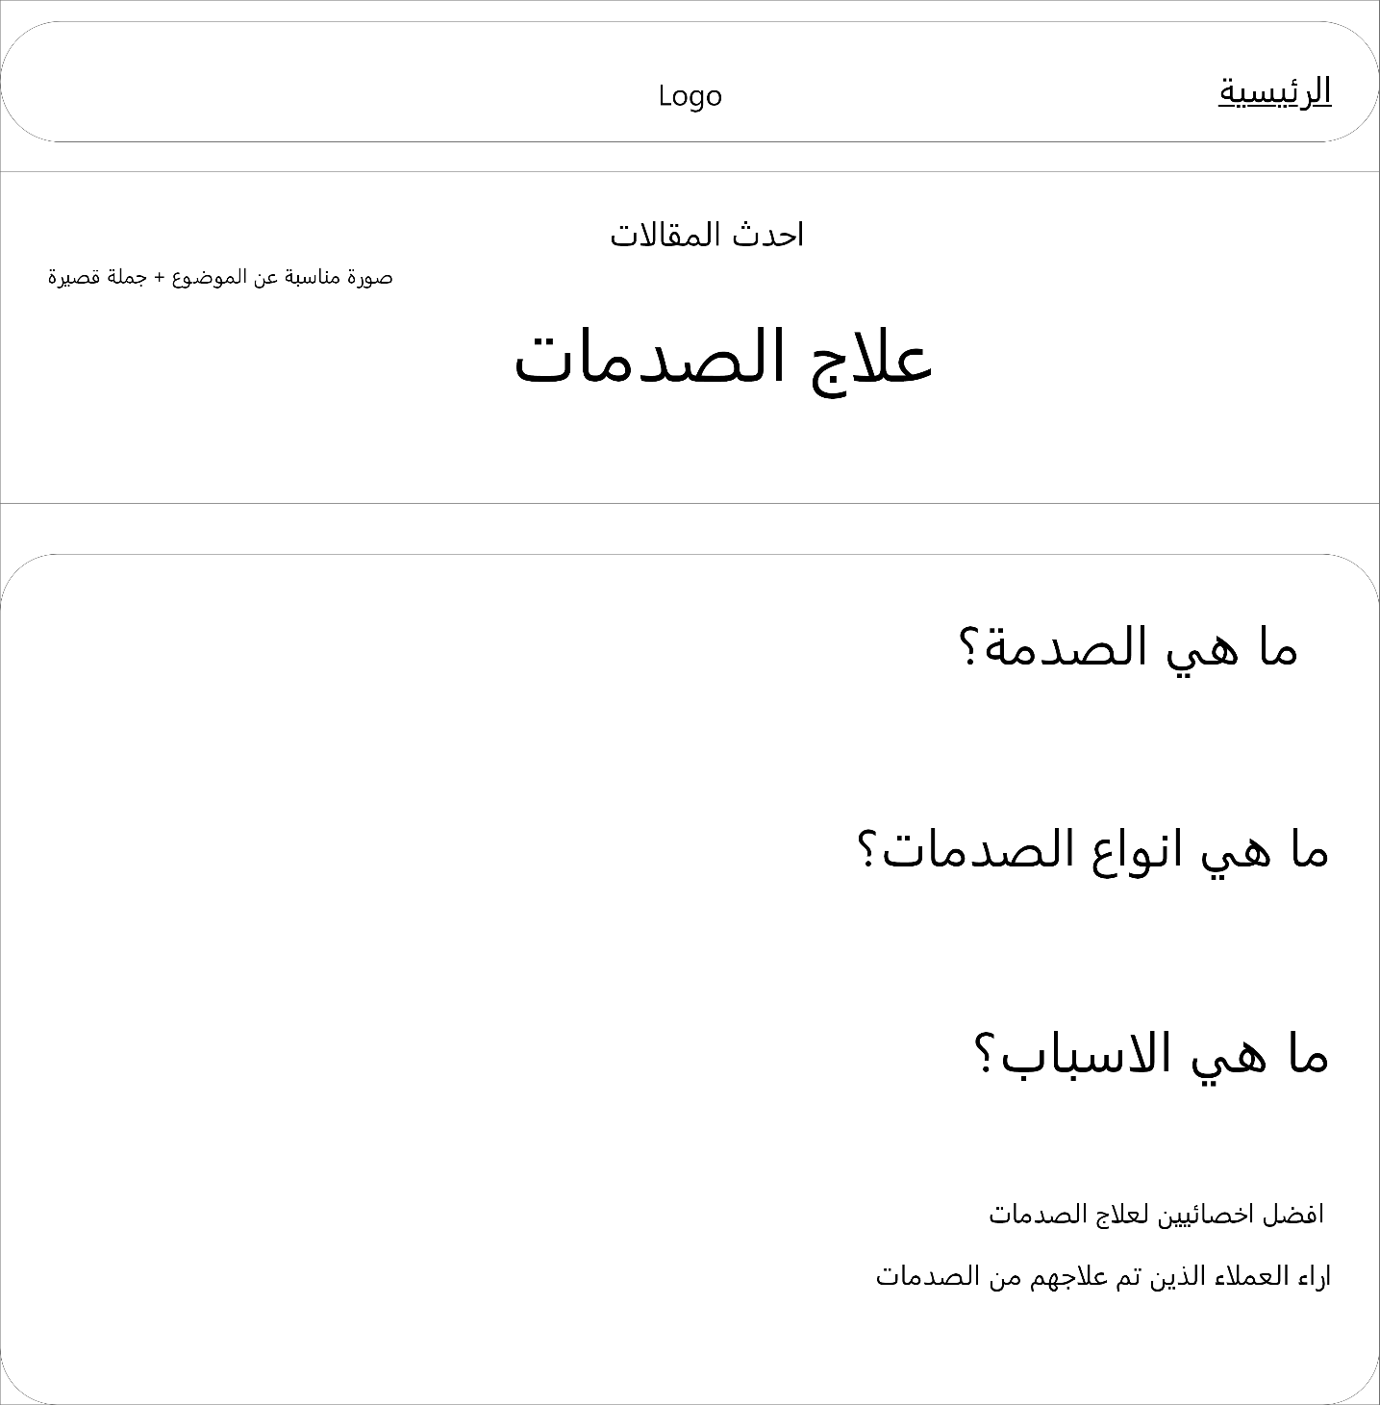
Figure ‎56: Wireframe Articles

